Fortune Telling with Gypsy Cards - Examples
In the following text I provide you with some examples with different gypsy card spreads. These examples serve as a reference on how to formulate your questions and what you can expect the answers to look like.

Spread with 1 card: Recommended for yes/no answers without further analysis
I am 23 years old and have a relationship with an older married man. I`m fell in love with him but I am not sure whether our relationship will continue, whether he loves me or he will leave his wife.
Question: Does he love me?
Answer
The following card shows the answer for your question: Falseness
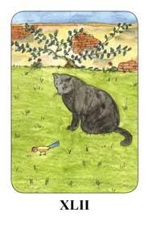 | Unfortunately the card says that his feelings are not real and he won`t leave his wife for you. Look at the picture: The man represents the cat that is playing with the little bird.

Spread with 3 cards: Quick spread for a concrete question
I could not find a job for more than one year now. I have a university degree in Human Resources and speak foreign languages. I have tried everything, but without success.
Question: I would like to know whether I will find a job in the next months or I if have to wait more even longer?
Answer
The following cards show the answer for your question: Journey, Victory and Marriage
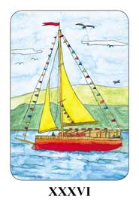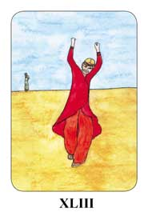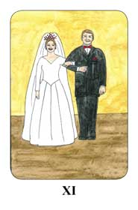
The cards clearly say that the changes will be triggered in the next months and you will get out of this bad situation as a winner. You will find a secure and stable job appropriate to your qualification, where you can develop and progress.
Example for spread with more cards with analysis: In this case the type of spread (quantity and disposition of cards) varies according to the question.
I am a 34 years old single woman. I would like to know whether something would happen in my future love life. I met someone, a lawyer who I like very much. He is a very nice person and I would like to have a relationship with him but he is very shy.
Question: Is there a chance for a relationship with him or will I have a relationship with another man in the near future?
Answer:
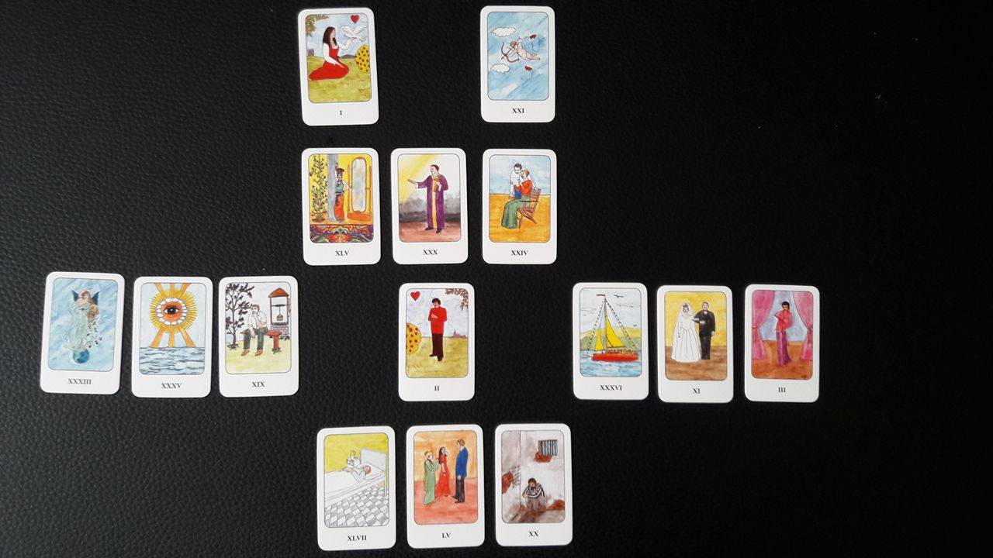
C
D
A
B

Dear XY,
Thank you for your trust; I hope my prediction meets your expectations and provides answers to your question. The following spread shows very well what the other party's (in this case your lawyer acquaintance) thoughts and feelings about you and what is projected to be between you both in the future.
As you can see, the top three cards (group "A" in the figure) show that your lawyer friend is attracted to you and feels good in your company; he likes spending his time with you. The problem is that he does not know enough about as you do not show your inner self. Therefore he believes you don't take him seriously, even though he wants to have a serious relationship and to find his soul mate.
The emotion cards (group "B" in the figure) show that he has no self -confidence, that`s why he is very shy and doesn`t dare to take any steps. You are a very attractive women and he thinks that he has no chance and believes there is another man around you - who appears as his rival in this spread - and he fears that this person will seduce you; which is also enforced by your behavior.
In the present situation (group "C" in the figure) both of you are thinking about the other, but because of his self-confidence problems there is no developing in this case. He is very closed and doubts you will have an future together.
The cards (group "D" in the figure) tell that everything depends on you. You have to take the first steps and show your emotions and that you are interested in a serious relationship with him. If you do this, he will feel himself more self-confident, his doubts and inhibitions will disappear and he will be able to open up emotionally with you and you can create a happy and stable relationship.
Good luck!
Love,
Abigail

